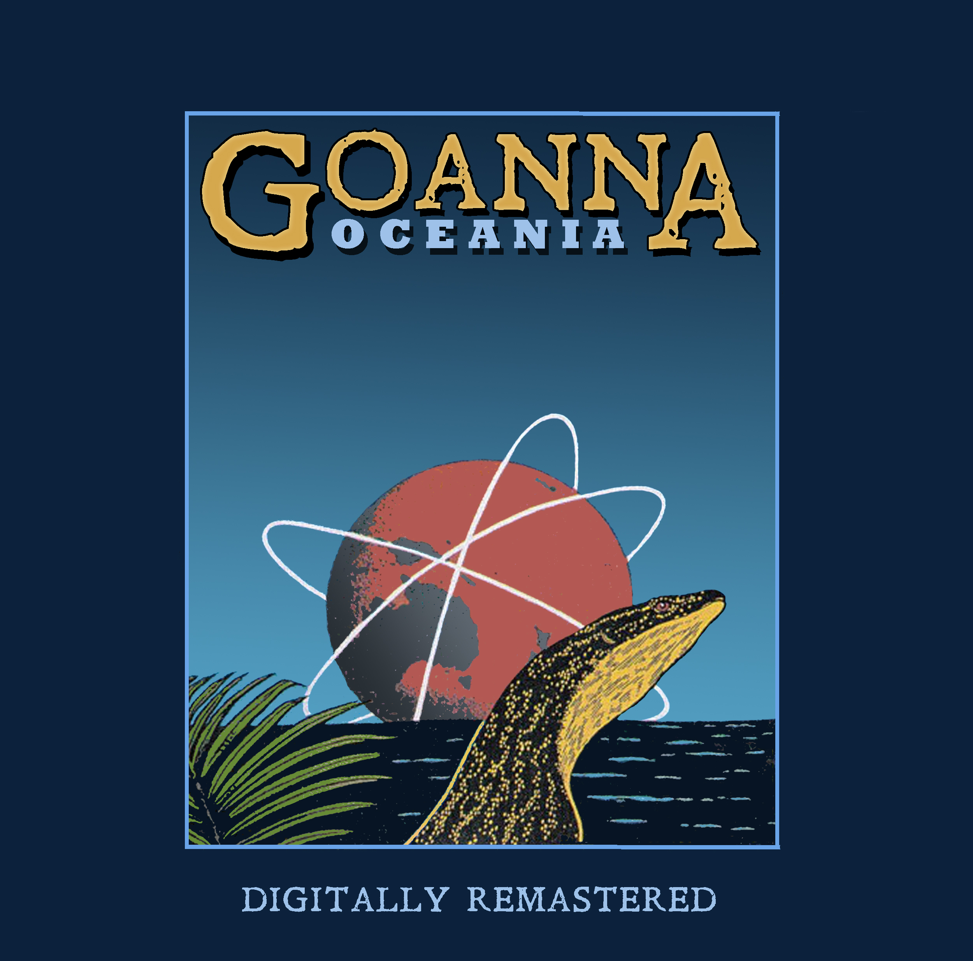

GOANNA - OCEANIA RE-RELEASE 2020 MEDIA RELEASE
___________________________________________________________________________________

35 years after its initial release, Goanna’s Oceania album is re-released through the Goanna Arts label.

For the first time, the album is available on digital platforms and available as a CD.

The entire restoration project has been lovingly overseen by Goanna founder and mainstay, Shane Howard. It’s taken almost 10 years to fully recover the album.

Oceania followed Goanna’s overwhelmingly successful debut album, Spirit of Place and was an ambitious undertaking. The album has hidden in the shadows of the wildly successful Spirit of Place album for decades.

While their hugely successful debut album, Spirit of Place, was immediately accessible, Oceania is richer, deeper and more complex, musically, lyrically and technically. Where Spirit of Place was an album for Australia, Oceania is boldly an album made for the world.

Oceania is epic.

Listening to the re-mastered release of the album, 35 years after it was first released on vinyl, is a powerful experience. The technical excellence of the musicianship and the recording puts you in mind of Steely Dan’s recordings.

Goanna had been through the wringer of commercial success and the grind of touring and were a seasoned outfit by the time they made Oceania.

Musically and lyrically, the album looks to the world from Australian eyes. The Cold War was still dominant and the fear of nuclear holocaust was real. The Soviet Union was on the edge of disintegrating and the US had begun its decline. Ronald Reagan and Margaret Thatcher were in power. Asia was just beginning to stir and take its place in world affairs. Environmental issues, gender equality and Indigenous rights were beginning to come to the fore.

The cover art for the1984 single release of Common Ground was a pastel drawing of Icarus in freefall by artist Dick Collis. The back cover contained the closing paragraph from Kenneth Clark’s, Civilisation: “We can destroy ourselves by cynicism and disillusion, just as effectively as by bombs. The moral and intellectual failure of Marxism has left us with no alternative to heroic materialism, and that isn’t enough.”

From the prophetic Common Ground, to the lost innocence of Utopia, Oceania marks the end of an era in many ways. Musically ambitious and sonically lush, it’s a towering work of musical and sonic excellence with a fascinating and troubled history.

“We initially met with Mark Knopfler to produce the album.” Says Howard. “He was very generous but he had prior commitments to the Sonic Youth album and we couldn’t afford to delay. There was a lot of love for the American band, Little Feat, a ‘band’s band’, founded by Lowell George and Bill Payne, so we invited Bill Payne, who we’d met on the James Taylor Tour, to take the role of producer, which he accepted.”

The album was mostly recorded in Australia with legendary engineer, the late John French, (Daddy Cool, Skyhooks, Mark Gillespie, Billy Thorpe, Russell Morris), at the helm.

John French was a veteran engineer by then, having recorded Daddy Cool’s – Eagle Rock, Spectrum, Skyhooks – Living In The Seventies, Billy Thorpe – Most People I Know Think That I’m Crazy, Russell Morris, The Dingoes, mercurial songwriter, Mark Gillespie and the soundtrack of surf alt-culture Morning of the Earth.

In the mid 1980s, John built a custom-made mud brick studio, Fast Forward, where Oceania was largely recorded.

Howard said, “He actually created the Australian rock sound. He was an excellent engineer. He had an artistic temperament and great taste in music. He knew how to get the best out of everyone but he wouldn’t suffer fools.”

French went on to mix half of the album.

The other half was mixed by audio pioneer, George Massenburg, (Randy Newman, James Taylor, Little Feat, Linda Ronstadt, Herbie Hancock, Dixie Chicks), at his studio and sonic laboratory, The Complex in Los Angeles. It’s also where Hideaway, a song co-written by Payne and Howard, was recorded with Payne on keyboards, Leland Sklar (James Taylor) on bass and David Platshon, (The Motels), on drums. Howard took Australian guitarist, Sam See and Ian Morrison with him. The band had first met Leland Sklar on the James Taylor tour in 1981, as well as Bill.

“To work with those exceptional musicians, with George Massenburg at the helm, who’d recorded so many extraordinary albums of our era, as well as those Little Feat albums, was a master class,” recalled Howard.

The re-release features a re-ordering of the songs as well as the bonus song, Dancing With The Lions, written and sung by Rose Bygrave, that never made the initial release.

“It was intended for the album but technical and logistical factors prevented that from happening. This version was recovered from rough mixes of the early album recordings and it’s appropriate to see it take its place in this body of work. Sadly, another great track, Marketplace, couldn’t be recovered technically and is lost to audio heaven,” says Howard.

A seasoned and accomplished core band is complemented by the masterful musicianship of guest performers.

Cameos abound from Payne, Eddie Rayner, (Split Enz), Ross Hannaford, (Daddy Cool), Venetta Fields, (Pink Floyd, Steely Dan, Ike & Tina Turner, John Farnham), Mal Logan, (The Dingoes, Renee Geyer, Little River Band), Greg Sheehan, (McKenzie Theory, Richard Clapton, Coolangubra), and Alex Pertout, (Australian Art Orchestra, Melbourne Symphony Orchestra, Senior Lecturer in the Jazz & Improv/Faculty of Arts & Music, University of Melbourne)

While their hugely successful debut album, Spirit of Place, was immediately accessible, Oceania is richer, deeper and more complex, musically, lyrically and technically. Where Spirit of Place was an album for Australia, Oceania is boldly an album made for the world.

“We wanted to make a record that was different in style and content from the Spirit of Place album. Oceania is musically adventurous and commercially outrageous. It’s a much more sophisticated record than Spirit of Place.”

“The record company head had said to me, “Just write another f***ing Solid Rock.”
I told him, “It doesn’t work like that”, said Howard. “So we made the second album ourselves and licensed it to the record company when we were finished.”

“By the time we got to Oceania, I’d travelled pretty widely and met a lot of Aboriginal people in a lot of different communities all over Australia. My eyes were wide open.”

“I’d also reached a point where I didn’t feel like I had the authority to comment on behalf of Aboriginal people. I’d met Aboriginal activists like Lionel Fogarty, Cheryl Buchanan and Dennis Walker and they acutely sharpened my political awareness of Aboriginal issues. Warumpi Band and others were emerging and I felt it wasn’t my place to comment anymore. The lyrical references are there on this album but they became more universal and maybe more cryptic.”

Howard says Goanna’s relationship with their record company at the time of the Oceania release was hostile and the promotion of the album suffered as a result.

After Oceania, Goanna toured solidly for nearly a year and then virtually disappeared. Burdened by debt and subsequent personal collapse, Goanna splintered and Howard disappeared into North Queensland and Aboriginal Australia. There were a few more tours, including a National Tour with Coloured Stone in 1987 and, in 1998, a third Goanna album, Spirit Returns, accompanied by two performances at the Melbourne Concert Hall.

Goanna flashed across the sky for a brief period in an era of Australian self-confidence. They left a lasting legacy. The song, Solid Rock, Sacred Ground, has become a beacon and a national compass bearing. Solid Rock, Razor’s Edge and Let The Franklin Flow and the album, Spirit of Place, are touchstones that have embedded even deeper, with the passing of time, into Australian consciousness.

To hear Oceania again, all these years later, is to be reminded of what a great, if unstable, musical force Goanna were and rediscovering Oceania is like uncovering a lost artefact from the golden age of analogue recording.

Together, the two albums compliment each other as polar opposites. The youthful vigour of Spirit of Place has been replaced by the lost innocence but musical assuredness of Oceania. The great tragedy was that circumstances robbed us of seeing how Goanna may have evolved.

Howard has been working on a memoir for some time now.
“For anyone who’s interested to understand what happened to Goanna, the forthcoming book might shed some light. The ‘music industry’ is just as capable of destroying careers as building them,” says Howard.

“Goanna was a crazy but purposeful collective of musicians and artists, trying to make great Australian music in the midst of a world ruled by greed and corporate shenanigans. We had a red hot go at creating music with an Australian identity and it nearly destroyed us, but we survived. The music remains.”

The third Goanna album, Spirit Returns, is also scheduled for re-release in October 2020.

∞•§Ω§•∞

